1. Flowchart: “./flowcharts/pbm.pdf”



**command**: ./rectangles 1 4 4 pbm_4_4_[ascii, raw] [0, 1]  
**location**: ./images/pbm_4_4_[ascii, raw].pbm  
  


**command**: ./rectangles 1 4 120 pbm_4_120_[ascii, raw] [0, 1]  
**location**: ./images/pbm_4_120_[ascii, raw].pbm

Image is completely black as the crosshairs overlap to cover the entirety of the white box.



**command**: ./rectangles 1 120 4 pbm_120_4_[ascii, raw] [0, 1]  
**location**: ./images/pbm_120_4_[ascii, raw].pbm

Image is completely black as the crosshairs overlap to cover the entirety of the white box.



**command**: ./rectangles 1 8 8 pbm_8_8_[ascii, raw] [0, 1]  
**location**: ./images/pbm_8_8_[ascii, raw].pbm



**command**: ./rectangles 1 8 16 pbm_8_16_[ascii, raw] [0, 1]  
**location**: ./images/pbm_8_16_[ascii, raw].pbm



**command**: ./rectangles 1 16 8 pbm_16_8_[ascii, raw] [0, 1]  
**location**: ./images/pbm_16_8_[ascii, raw].pbm

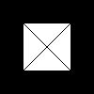

**command**: ./rectangles 1 100 100 pbm_100_100_[ascii, raw] [0, 1]  
**location**: ./images/pbm_100_100_[ascii, raw].pbm

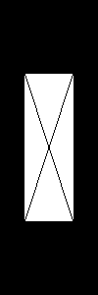

**command**: ./rectangles 1 100 300 pbm_100_300_[ascii, raw] [0, 1]  
**location**: ./images/pbm_100_300_[ascii, raw].pbm

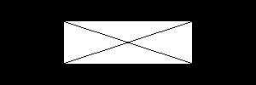

**command**: ./rectangles 1 300 100 pbm_300_100_[ascii, raw] [0, 1]  
**location**: ./images/pbm_300_100_ [ascii, raw].pbm

1. Flowchart: “./flowcharts/pgm.pdf”



**command**: ./rectangles 2 4 4 pgm_4_4_[ascii, raw] [0, 1]  
**location**: ./images/pgm_4_4_[ascii, raw].pgm  
  


**command**: ./rectangles 2 4 120 pgm_4_120_[ascii, raw] [0, 1]  
**location**: ./images/pgm_4_120_[ascii, raw].pgm

The black gradient in the image is mixing with the background black in the middle of the rectangle because of the tiny width.



**command**: ./rectangles 2 120 4 pgm_120_4_[ascii, raw] [0, 1]  
**location**: ./images/pgm_120_4_[ascii, raw].pgm

The black gradient in the image is mixing with the background black in the middle of the rectangle because of the tiny height.



**command**: ./rectangles 2 8 8 pgm_8_8_[ascii, raw] [0, 1]  
**location**: ./images/pgm_8_8_[ascii, raw].pgm



**command**: ./rectangles 2 8 16 pgm_8_16_[ascii, raw] [0, 1]  
**location**: ./images/pgm_8_16_[ascii, raw].pgm



**command**: ./rectangles 2 16 8 pgm_16_8_[ascii, raw] [0, 1]  
**location**: ./images/pgm_16_8_[ascii, raw].pgm

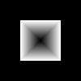

**command**: ./rectangles 2 100 100 pgm_100_100_[ascii, raw] [0, 1]  
**location**: ./images/pgm_100_100_[ascii, raw].pgm

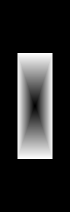

**command**: ./rectangles 2 100 300 pgm_100_300_[ascii, raw] [0, 1]  
**location**: ./images/pgm_100_300_[ascii, raw].pgm

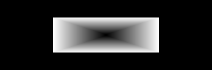

**command**: ./rectangles 2 300 100 pgm_300_100_[ascii, raw] [0, 1]  
**location**: ./images/pgm_300_100_ [ascii, raw].pgm

1. Flowchart: “./flowcharts/ppm.pdf”



**command**: ./rectangles 3 6 4 ppm_6_4_[ascii, raw] [0, 1]  
**location**: ./images/ppm_6_4_[ascii, raw].ppm  
  


**command**: ./rectangles 3 4 120 ppm_4_120_[ascii, raw] [0, 1]  
**location**: ./images/ppm_4_120_[ascii, raw].ppm

Red, Green, and Blue gradients appear on the top, and two gray gradients appear on the bottom.



**command**: ./rectangles 3 120 4 ppm_120_4_[ascii, raw] [0, 1]  
**location**: ./images/ppm_120_4_[ascii, raw].ppm

Gradient in rectangles is divided into 2 sections for each color. Making the picture look like it is containing 10 different rectangles.



**command**: ./rectangles 3 12 8 ppm_12_8_[ascii, raw] [0, 1]  
**location**: ./images/ppm_12_8_[ascii, raw].ppm



**command**: ./rectangles 3 12 16 pgpm_12_16_[ascii, raw] [0, 1]  
**location**: ./images/ppm_12_16_[ascii, raw].ppm



**command**: ./rectangles 3 24 8 pgm_24_8_[ascii, raw] [0, 1]  
**location**: ./images/pgm_24_8_[ascii, raw].pgm

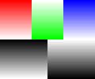

**command**: ./rectangles 3 120 100 ppm_120_100_[ascii, raw] [0, 1]  
**location**: ./images/ppm_120_100_[ascii, raw].ppm

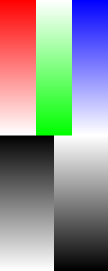

**command**: ./rectangles 3 120 300 ppm_120_300_[ascii, raw] [0, 1]  
**location**: ./images/ppm_120_300_[ascii, raw].ppm

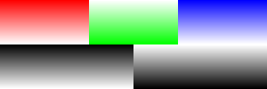

**command**: ./rectangles 3 300 100 ppm_300_100_[ascii, raw] [0, 1]  
**location**: ./images/ppm_300_100_ [ascii, raw].ppm  
  


**command**: ./ppm_to_pgm  
**location**: ./images/ppm_300_100.R.ppm

The red rectangle becomes completely white because we transform with respect to the red channel. The green and blue become gray gradients.  
  
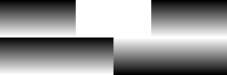

**command**: ./ppm_to_pgm  
**location**: ./images/ppm_300_100.G.pm

The green rectangle becomes completely white because we transform with respect to the green channel. The red and blue become gray gradients.  
  
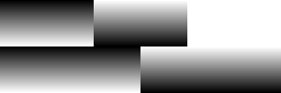

**command**: ./ppm_to_pgm  
**location**: ./images/ppm_300_100.B.ppm

The blue rectangle becomes completely white because we transform with respect to the blue channel. The red and green become gray gradients.